SAINTGITS COLLEGE OF APPLIED SCIENCES
First Internal Assessment Examination, February 2020
B. Com Fourth Semester (Computer Applications)
INFORMATION TECHNOLOGY FOR BUSINESS
Total : 50 marks Name………………………
Time : 2 Hours Roll No ……………………
Section A
Answer any 5 questions. Each question carries 2 marks.
- What is a word processor?
- What is the use of slide master in power point?
- Explain Read mode and Draft mode
- What is the use of Insert Tab?
- What is a nested table?
- List any 4 advantages of PowerPoint presentations.
(5 X 2 = 10 marks)
Section B
Answer any 5 questions. Each question carries 5 marks.
- Explain the different means of viewing word documents
- List down the elements of the status bar.
- What is Find and Replace option in word 2013. Write the steps for replacing a word in Word 2013.
- How will you add videos into a MS power point presentation?
- Explain ways to add a section break and to link it in the document?
- What are the different elements in Ribbon? (5 X 5 = 25 marks)
Section C
Answer any 1 question. It carries 15marks.
- List down new basic features of Word 2013.
- Explain the different elements of screen layout in PowerPoint presentation?
(1 X 15 = 15 marks)

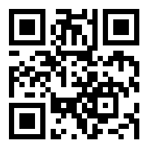

Scan QR code for the answer scheme

