SAINTGITS COLLEGE OF APPLIED SCIENCES
First Internal Assessment Examination, February 2020
B.Com Second Semester (Computer Applications& Taxation)
BUSINESS REGULATORY FRAMEWORK
Total : 50 marks Name………………………
Time : 2Hours Roll No ……………………
Section A
Answer any 5questions. Each question carries 2 marks.

- What is Estoppel?
- What is revocation?
- Who is a stranger to contract?
- Define Coercion.
- What is Mistake?
- What is a contingent contract?
(5 X 2 = 10 marks)
Section B
Answer any 5 questions. Each question carries 5 marks.
- Differentiate between void agreements with illegal agreements and void contracts.
- What are the different types of offer?
- Explain who all are incompetent to enter the contract.
- Explain the agreements opposed to public policy.
- Define consideration. Explain the essentials of valid consideration.
- What is appropriation of payments? (5 X 5 = 25 marks)
Section C
Answer any 1 question. It carries 15marks.
- Define contract. Explain the essentials of a valid contract.
- Explain the rules regarding minor agreements.
(1 X 15 = 15 marks)

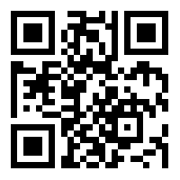

Scan QR code for the answer scheme

