SAINTGITS COLLEGE OF APPLIED SCIENCES
PATHAMUTTOM, KOTTAYAM
First Internal Assessment Examination, September 2018
B.Com First Semester (Computer Applications &Taxation)

Quantitative Techniques for Business – I
Answer scheme
Section A
1.weighted average method is used when:
- Importance of all items in a series is not equal
- Ratios, percentages or rates are being averaged.
- Classes of the same group contain widely varying frequencies.
- Birth rate, death rate, index numbers are calculated.
2.Statistics in plural sense:
Horace Secrist defines statistics as ‘ aggregates of facts affected to a marked extent by multiplicity of causes numerically expressed, enumerated or estimated according to reasonable standards of accuracy, collected in a systematic manner for a pre- defined purpose and placed in relation to each other.
Statistics in singular sense:
Seligman defines statistics as ‘the science which deals with the methods of collecting, classifying,presenting, comparing and interpreting numerical data to throw some light on any sphere of enquiry’.
3. Let no: of boys be X
No: of girls = 150 –X
60 = X x 70 + (150 – X) x 55
150

60 x 150 – 55 x 150 = 70 X - 55 X

X = 5 x 150
15
= 50
ie no: of boys = 50 and no: of girls = 150-50 = 100
4. Reasons for distrust of statistics:
- Easy to manipulate
- Lacks accuracy
- Inappropriate comparisons
- Possible to deliberately twist facts
- Inconsistent definitions
5. Calculation of Harmonic mean:
X 1/X
10 0.1
20 0.05
30 0.033
40 0.025
50 0.02
0.228
H.M =N
∑1/X = 5
0.228
= 21.93
6. inclusive series: 0 -9 ,10 -19, 20-29, 30-39, 40-49
Exclusive series: 0-10, 10-20, 20-30, 30-40, 40-50
Open –ended series: below10, 10-20, 20-30, 30-40, 40-50, above 50
Section B
7. Merits and demerits of Arithmetic Average.
Merits:
- It is rigidly defined and no scope for ambiguity or misunderstanding
- Easy to understand and calculate
- It is based on all the items of a series
- It is not very much affected by fluctuations in sampling.
- Its capable for further algebraic treatment.
- It is the center of gravity.
Demerits
- It cannot be located by inspection
- It cannot be located graphically.
- It cannot be used in the study of qualitative phenomena like intelligence., beauty etc.
- It is greatly affected by extreme values.
- It is not suitable for averaging ratios and percentages.
8. Missing frequency
16.82 = 1165 + 17.5 x / 70 + x
X = 18
9. Essential characteristics of an ideal average.
Simplicity, Representation, Rigidly Defined, Algebraic Treatment, Clear and Stable definition, Absolute Number
10. Geometric Mean= Antilog (∑log x / N)
Antilog (6.4676/3)
Antilog 2.1559
GM= 143.2
Average rate of increase = 143.2 – 100 = 43.2
11. Finding Median Graphically

The median value of a series may be determinded through the graphic presentation ofdata in the form of Ogives.This can be done in 2 ways.

1. Presenting the data graphically in the form of 'less than' ogive or 'more than' ogive .2. Presenting the data graphically and simultaneously in the form of 'less than' and'more than' ogives.The two ogives are drawn together.

1.Less than Ogive approach
Marks Cumulative Frequency (C.M)Less than 419.5 14Less than 429.5 34Less than 439.5 76Less than 449.5 130Less than 459.5 175Less than 469.5 193Less than 479.5 200
Steps involved in calculating median using less than Ogive approach -1. Convert the series into a 'less than ' cumulative frequency distribution as shownabove .2. Let N be the total number of students who's data is given.N will also be thecumulative frequency of the last interval.Find the (N/2)thitem(student) and mark it on they-axis.In this case the (N/2)thitem (student) is 200/2 = 100thstudent.3. Draw a perpendicular from 100 to the right to cut the Ogive curve at point A.4.From point A where the Ogive curve is cut, draw a perpendicular on the x-axis. Thepoint at which it touches the x-axis will be the median value of the series as shown inthe graph.
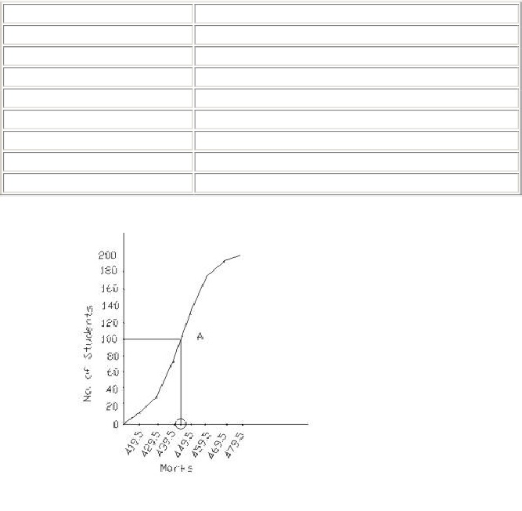
The median turns out to be 443.94.
2.More than Ogive approach
More than marks Cumulative Frequency (C.M)More than 409.5 200More than 419.5 186More than 429.5 166More than 439.5 124More than 449.5 70More than 459.5 25More than 469.5 7More than 479.5 0
Steps involved in calculating median using more than Ogive approach -1. Convert the series into a 'more than ' cumulative frequency distribution as shownabove .2. Let N be the total number of students who's data is given.N will also be thecumulative frequency of the last interval.Find the (N/2)thitem(student) and mark it on they-axis.In this case the (N/2)thitem (student) is 200/2 = 100thstudent.
3. Draw a perpendicular from 100 to the right to cut the Ogive curve at point A.4.From point A where the Ogive curve is cut, draw a perpendicular on the x-axis. Thepoint at which it touches the x-axis will be the median value of the series as shown inthe graph.
The median turns out to be 443.94.
3.Less than and more than Ogive approach
Another way of graphical determination of median is through simultaneous graphicpresentation of both the less than and more than Ogives.
1.Mark the point A where the Ogive curves cut each other.2.Draw a perpendicular from A on the x-axis. The corresponding value on the x-axiswould be the median value.
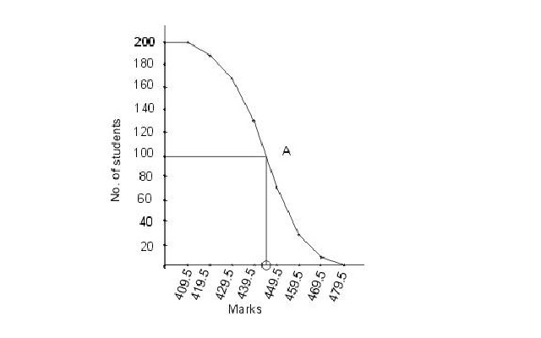
The median turns out tobe 443.94.
12. ∑ x= 50 * 100= 5000
Incorrect ∑x= 5000
Correct ∑x = Incoorect∑x – Incorect item + Correct item
Correct ∑x= (5000-78) + 87 = 5009
Correct Mean= Correct ∑x / N = 5009/100 = 50.09

13. M= Size of N/2th item= 25th item
M=L+ (N/2 – C.f )/f * C
L= 20
C.f =10 , f= 20 ,C=10
27.5
40% of 50 = 20
21st person passed
M= 20+ (21-10)/20 * 10
25.5
14.
f =40,20,15,15,15,5,2,1,7
∑fx=3150
∑ f=120
Mean = ∑fx /∑f =26.25

