SAINTGITS COLLEGE OF APPLIED SCIENCES
PATHAMUTTOM, KOTTAYAM
First Internal Examination September 2018
B.Com Third Semester (Computer Applications&Taxation)
MARKETING MANAGEMENT

Total Marks: 50 Name :……………………
Time: 2 hours Roll No:……………………

Section A
Brief answer questions. Answer any 5 questions. Each question carries 2 marks

1. Briefly explain the levels of a product?
2.What is marketing myopia and USP?
3. What is holistic marketing concept?
4. Explain briefly any three classifications of markets on the basis of geographical area.
5. What are the levels of market segmentation?
6. Write any two differences of marketing and selling? (5 × 2 = 10marks)
Section B
Short essay questions. Answer any 5 questions. Each question carries 5 marks

7. Explain the basis of segmentation?
8.What is Positioning?What are the different market positioning strategies?
9. What are the different concepts of marketing?
10.What is targeting? What are the different target marketing strategies?
11.Explain marketing mix.
12. Explain Buyer Decision Process. (5 × 5 = 25 marks)
Section C
Essay questions. Answer any one question. Carries 15 marks

13. Explain STP.
14. What is a new product? Explain the stages involved in the product development.
(1 × 15 = 15 marks)
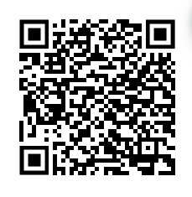

Scan QR code for the answer scheme

