SAINTGITS COLLEGE OF APPLIED SCIENCES
Internal Assessment Examination, September 2019
B.Com Third Semester (Computer Applications)
INFORMATION TECHNOLOGY FOR BUSINESS
Total : 80 marks Name………………………
Time :3Hours Roll No ……………………
Section A
Answer any 10 questions. Each question carries 2 marks.
1. What is an MICR scanner?
2. Explain the term informatics.
3. What is system software?
4. Explain cyber crimes.
5. What is Wimax?
6. What is LAN?
7. What is an attribute?
8. What is a definition list?
9. What is a modem?
10. What are crawlers?
11. What is a marquee?
12. What do you mean by topology? (10 X 2 = 20 marks)
Section B
Answer any 6 questions. Each question carries 5 marks.
13. Write a note on the free software movement.
14. What are the different types of printers?
15. Write a note on computer and health issues.
16. Explain the benefits of Networks.
17. What do you mean by cyber ethics?
18. Write a note on dynamic and static websites.
19. Write a note on DNS.
20. What is W3C?
21. What are the different types of search engines? (6 X 5 = 30marks)
Section C
Answer any 2questions. It carries 15marks.
22. Write a note on Virtual Reality.
23. Explain the significance of network security.
24. Discuss the application of IT in commerce, business and industry.
25. Write a note on the benefits of Internet.
(2 X 15 = 30 marks)

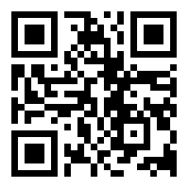
Scan QR code for the answer scheme

