SAINTGITS COLLEGE OF APPLIED SCIENCES
PATHAMUTTOM, KOTTAYAM
First Internal Assessment Examination, September 2018
B. Com Third Semester (Computer Applications & Taxation)
FINANCIAL MARKET AND OPERATIONS
Total: 50 marks Name ………………….
Time: 2 Hours Roll Number ……………
Section A
Answer any 5 questions. Each question carries 2 marks.

1. What do you mean by financial system?
2. What do you mean by capital market?
3. Explain Commercial Paper?
4. List out the Objectives of SEBI.
5. What do you mean by derivatives?
6. Differentiate between savings and investment. (5 X 2 = 10 marks)
Section B
Short essay questions
Answer any 5 questions. Each question carries 5 marks.

7. Differentiate between Money market and Capital market.
8. What do you mean by Commercial bills? Explain the major types of bills
9. Explain the major components of capital market.
10. Explain the major types of derivatives.
11. List out the recent changes in the Indian Financial system.
12. Explain the measures adopted by RBI in controlling money supply. (5 X 5 = 25 marks)
Section C
Long essay questions
Answer any 1 question. It carries 15 marks.

13.what do you mean by capital market and money market. Explain the major money market and capital market instruments.
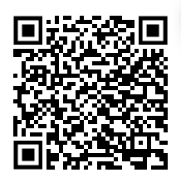
14. Explain the components of financial system with the help of a diagram. (1 X 15 = 15 marks)

Scan QR code for the answer scheme

