Business Communication, October 2019
Answer Key

BUSINESS COMMUNICATION & MANAGEMENT INFORMATION SYSTEM
Section A
1. What is Haptics?
Haptic communication is a form of nonverbal communication and the way by which people and animals communicate via touching.Touch is the most effective means to communicate feelings and emotions.

2.What is meant by Transactional Analysis?
Transactional Analysis (or TA) is a model of communication. It was developed during the 1960s by Eric Berne, a Canadian-born psychiatrist and is based on the premise that we always converse and communicate with others from one of three parts or "ego-states" of our personality. Knowing that we can choose which ego-state to communicate from means that we can make choices about how an exchange with someone is going to develop and whether we want it to succeed or not.

3.What are periodic reports?
A report published at a fixed interval, summarizing the events that occurred during that period. Eg: daily report, weekly report, monthly report etc.

4. Define Resume.
A resume is a one- or two-page formal document that job hopefuls submit to hiring managers and employment recruiters as a means of itemizing their work experience, educational background, and special skills. Successful resumes entice potential employers to invite applicants to interview for the position. Resumes are traditionally accompanied by cover letters, in which applicants champion their relevant skills and tout their specific qualifications for a given position.

5. What is Power of Attorney?
A power of attorney (POA) is a legal document giving one person the power to act for another person (the principal). The agent can have broad legal authority or limited authority to make legal decisions about the principal's property, finances or medical care. The power of attorney is frequently used in the event of a principal's illness or disability, or when the principal can't be present to sign necessary legal documents for financial transactions.

6.What is affidavit?
n affidavit is a formal written statement setting out the facts of your case. The affidavit becomes evidence in your case. . It is the main way you present evidence (facts of the case) to a court.It must be sworn, or affirmed, usually before a Justice of the Peace, Commissioner of Oaths or solicitor, as a true record. Affidavits may also be sworn by other people in support of your case e.g. witnesses. The court has a precedent form to use

7. Define Archie.
Archie is a program that allows you to search the files of all the Internet FTP servers that offer anonymous FTP. Archie is actually an indexing spider that visits each anonymous FTP site, reads all the directory and file names, and then indexes them in one large index.

8. Define decision support system
.A decision support system (DSS) is an information system that supports business or organizational decision-making activities. DSSs serve the management, operations and planning levels of an organization (usually mid and higher management) and help people make decisions about problems that may be rapidly changing and not easily specified in advance—i.e. unstructured and semi-structured decision problems. Decision support systems can be either fully computerized or human-powered, or a combination of both.

9. What is TPS?
TPS stands for transaction processing systems. TPS is defined as "a computer - based information system that keeps track of the transactions needed to conduct business"

10. What is ERP?
"ERP" stands for enterprise resource planning. It refers to a suite of software that organizations use to manage day-to-day business activities, such as accounting, procurement, project management, risk management and compliance, and supply chain operations. A complete ERP suite also includes enterprise performance management, software that helps to plan, budget,
predict, and report on an organization’s financial results.

11. Define Business communication.
Business communication is information sharing among people within and outside an organization that is performed for the commercial benefit of the organization.

12. What is meant by testimonial?
-a written declaration certifying to a person's character, conduct, or qualifications, or to the value, excellence, etc., of a thing; a letter or written statement of recommendation.
-something given or done as an expression of esteem, admiration, or gratitude.

Section B
13. Explain the channels of communication.
- External communication
- Outward communication: all messages that go out of any organisation to other business houses, government offices, press , customers, suppliers are outward communication
- Inward communication: when an organisation receives messages from outside that is called inward communication.
B. Internal communication
- Formal communication : it is associated with a formal organizational structure. The communication flows through formal channels.
Types of formal communication are;
Vertical, horizontal and diagonal.
2. Informal communication: it originates from man's instinct to communicate or talk whatever he feels or thinks with his fellow beings. Informal communications may be of two types;
●Social gatherings - this emerge due to the social nature of human beings. They are not deliberately formed.
●Grapevine- The informal communication is also known as grapevine. It is not planned or deliberately created channel of communication. It grows spontaneously from personal and group interest.

14. Describe the principles of effective communication.
- Clarity - The message whether oral or written should be clear when it is communicated. The principle of clarity implies both clarity of thought and clarity of expressions.
- Completeness - the message should be complete. Oral presentations, dialogues etc should be planned and structured properly.
- Concreteness- the communicator must be specific and definite in describing the message.
- Conciseness- the message should be brief and it should be expressed with minimum words.
- Correctness - the speaker must use communication with correct grammar inorder to avoid mistakes in communication.
- Courtesy- the speaker should maintain a proper etiquette of speaking.
- Candidness- in oral communication the key element which creates an impact on listeners is confidence. It displays the self confidence of the speaker.

15. What is Proxemics? Explain in detail.
Proxemics is the study of space language. It means how we communicate with the space around us. Proxemics has to be regarded as Personal Space language.
● Intimate space language- Most important and intimate body language is used within this circle and is extended from physical contact to 18 inches.
● Personal space language- communication in this circle is mostly personal in nature , it is relaxed and casual for most of the time. The space language extended to 18 inches to 4 feet.
● Social space language- this space language extends from 4 feet to 12 feet and used for formal and official relationships.
● Public space language- it ranges from 12 feet to the farthest distance one can see. Our voice might be ra8sed to be heard by others or by a larger group in this space.

16. What are the components of IT ?
- Computers- this is the central component of IT and ranges from microchip based personal computers to super computers.
- Telecommunications- with recent advancements in the digital telecommunication field, this has become a critical partner in the IT area. By networking company across geographical and organizational boundaries and linking customers, suppliers with the organization, the power of computers is multifaceted and manifold.
- White collar productivity tools- personal productivity tools like word processing software, spreadsheet, project management software, etc would be included.
- Blue collar productivity tools- the most popular component in this category would be industrial robots, which performs a lot of tasks of the shop floor.
- Smart products- image processing software, interactive voice response systems etc from this category.

17. What are the features of Internet?
- Simplicity- It is easy to learn and simple to use the software that accesses the internet (web browser software).
- Economy- The cost involved in conducting a process through internet technology is less than these involving other methods.
- Flexibility of communications- The web browsers greatly extend the ways in which people can communicate each other.
- Speed and Availability- Composed to other medium of communication it is indeed fast.
- Accessibility- Internet is a global network and its access is not conditional by geographic boundaries,
- Resource Sharing- Internet allows the IT resources to be shared by multiple users,
- Security- In Internet, security has been a major concern because any security breach may result in financial loss, leakage of sensitive or confidential information etc,
- Synergy with other media- Internet services have demonstrated a high degree of synergy with other media.

18. Define legal drafting? Explain importance of legal drafting?
Legal drafting is a technical writing used by lawers, judges, legislators and others in law to express legal analysis and legal rights, privileges, functions, status and duties.
Drafting is of importance for the three reasons
- For obtaining legal consultations
- For carrying out documentation
- For interpretation of the documents,
Legal drafting have been categorised into three formes
- Document- A Document is a paper or other material thing giving information, proof or evidence of anything.
- Instrument - Instrument means a formal legal document, which creates or confirms a right or records a fact.
- Deed- The legal glossary defined ‘deed’ instrument in writing (or other legible representation or words on parchment or paper) purporting to effect some legal disposition.

19. Define Voice Mail? Explain its advantages?
When e-mail exchanges text data, voice mail transmits digitized voice messages. Voice mail system is a centralized computerized system used for sending, storing and retrieving audio messages, just like an answering machine would do at home.

ADVANTAGES OF VOICEMAIL
A Voicemail system can-
1.Answer many phones at the same time,
2,Store incoming voice messages in personalised mailboxes with the users phone number.
3..Enable users to forward received messages to another voice mail boxes.
4..Send messages to one or more other user voice mail boxes.
5.Add a voice introduction for a forwarded message.
6..Store voice messages for future delivery.
7..Make calls to a telephone or paging service to notify the user a message has arrived in his/her mailbox.
8..Provide message notification by SMS, a special dial tone, or using caller ID signaling
9.Transfer callers to another phone number for personal assistance.
10..Play different message greetings to different callers.

20. Explain the Essentials Of Good Information System?
1.Accuracy and Timeliness- The collected information must be accurate and must be available in time otherwise, its use would be limited,
2.Quantitative Adequacy- It means information must be sufficent in quantity to suit the needs of the organisation,
3.Completeness- Information provided to a manager must be complete and should meet the needs of user in all respects,
4.Relevance- It is key attribute of IS which states that it should serve reports to managers which are relevant and useful for decisionmaking.
5.Explicitness- A good report does not require further analysis by the recipient for decisionmaking.
6.Exception-based- As per the principles of management by exception, top managers need only exception reports regarding the functioning of the organisation.
7.Cyclical flow- The information must f;low constantly otherwise, its use would be limited.
8.Designing of tools according to the needs- An ideal IS should not be a prestigous showpiece.
9,Economic value- The economic value of information is measured by the gain acheived from using it.
10.Recipient point of view- The information conveyed to a receiver should infuse the desired knowledge in him.

21. Mention some of advantages of Teleconferencing?
1.Teleconferencing reaches large or sparsely- populated areas.
2. Teleconferencing provides broader access in public meetings as well as widening the reach of public involvement.
3. Audio interaction makes dialogue more lively, personal and interesting and provides an immediate response to concerns or issues
4.It enables people with disabilities, the elderly and others to participate without having to travel.
5.Teleconferencing saves people money- It saves travel time, transportation cost, cost of hotel accomodation and lost work time,
6. Teleconferencing saves time by reaching more people with fever meetings.
7.People including guest speakers, who wouldnt normally attend face to face(FTF) meeting can participate,
8. Follow up to earlier meetings can be done with relative ease and little expense.
9.Since socialising is minimal compared to an FTF Meeting meetings are shorter and are more oriented to the primary purpose of the meeting.
10.Communication between the home office and field staff is maximized,
11.Routine meetings are more effective since one can audio conference from any location equipped with a telephone.
12.Severe climate/ unreliable transportation may necessitate teleconferencing.
13. Teleconferencing is particularly satisfactory for simple problem solving, information exchange and procedural needs.
14.Group members participate more equally in well-moderated teleconferences than in an FTF Meeting.
15.It is very effective in training- It opens up training hours and availability of courses for people unable to take specialised classes because of time constraints and travel costs.

Section C
23. What is a business letter? What are the main parts of business letter?
Business letters are those letters written to firms and companies, customers, suppliers, associate organisations, government offices, credit agencies, employees etc. They are used to sell products, request material or information, answering customer enquiries, maintain good public relations, and to serve a variety of other business functions.
Parts or structure of business letters

- Headings: letter heads- Name Address, telephone number, email id, telegraphic address usually given at the top centre or top right side of the paper.
- Date:important point of reference to future. Placed two line spaces below the heading on the right.Written in full
- Reference: appears on the left on level with date.Includes letter number, file number, and other filing details.
- Inside address: Name and address of the organisation or individual to whom the letter is sent should be written below the reference No. line. Address should be complete and should not be abbreviated.
- Attention Line: letter addressed to a firm or company is marked to a particular person in that firm. To ensure prompt attention.
- Salutation: Greeting of the addressee.Varies according to the formality or intimacy.
- Subject line: to enable the reader to know immediately what the message is about.
- Body of the letter: The purpose of the body is to convey the message. Three parts:the first part contains a brief introduction, the second part contains relevant facts in a logical order and the third part is the close with a positive note.
- Complimentary close: polite way of ending the letter.
Salutation Complimentary close
Sir Yours faithfully or Yours respectfully
Dear sir Yours faithfully or Yours Truly
Dear Mr. Thomas Yours sincerely
Dear customer Yours Sincerely
- Signature: signed name of the sender placed below the complementary clause
- Enclosures: If there is anything attached to the letter, it must be shown against the enclosure line.
- Postscript: P S is written if the sender has forgotten to mention something important in the letter.
- Cc or Carbon copy: Some copies of the letter may be sent to other people.
- Reference initials: Many firms are following the practice of putting the initials of the person who dictates the letter and those of the ones who types it. The initials are beneficial for office checking. They can be typed to the left margin in the end.
24. Explain in details barriers of communication and how to overcome barriers.
- Physical barriers b. Semantic Barriers
- Noise 1. Different languages

- Improper time and distance 2. Different meanings for the same words
- Defects in the medium 3. Poor vocabulary
- Information overload 4. Vague presumptions
5. Inconsistent verbal and non- verbal communication

C. Organisational Barriers d. Socio- Psychological Barriers
- Hierarchy in organisation 1. Emotions
- Organisational rules and regulations 2. Poor listening
- Wrong choice of channel 3. Poor retention
- Non- conduct of staff meeting 4. Attitudes and opinions
- Restrictive environment 5. Premature evaluation
- Insufficient period of time 6. Status Consciousness
7. Goal-conflicts
8. Filtering

E. Cultural Barriers.
- Value
- Social relationships
- Thought processes
Overcome Barriers
- To give proper training in effective communication to persons in authority and subordinates
- To review and reorganise the communication network in the organisation periodically
- To provide the staff with medical and recreation to keep down stress level
- To allow vacation to the employees to avoid stress and fatigue
- To cultivate all communication skills including getting feedback and non- verbal communication
- To keep the channels of communication in good working condition.
- To become careful with regard to use correct language and words
- To make use of short and simple sentences and visual aids whenever possible.
- To reduce misunderstanding when communicating with people from different cultures
- To maintain adequate contact with subordinates and encourage two- way communication
- To make use of multiple channels of communication including face-to face conversation,and periodic group meetings
- To make best use of body language
- To encourage open communication policy where employees are encouraged to approach immediate superior with any manner.
- To follow a policy of effective listening

25. Prepare a partnership deed contents and samples.
Contents
Name of the firm
Names and addresses of all partners
Nature and duration of business of the firm
The amount of capital contributed by each partner
The ratio in which the partners are to share profits and losses
Amount of Salary or commission payable to partners
Rate of interest on capital and drawings
Settlement of accounts in the event of dissolution
Arbitration in case of disputes between partners
Any other matters which may be found necessary
Sample of a partnership deed
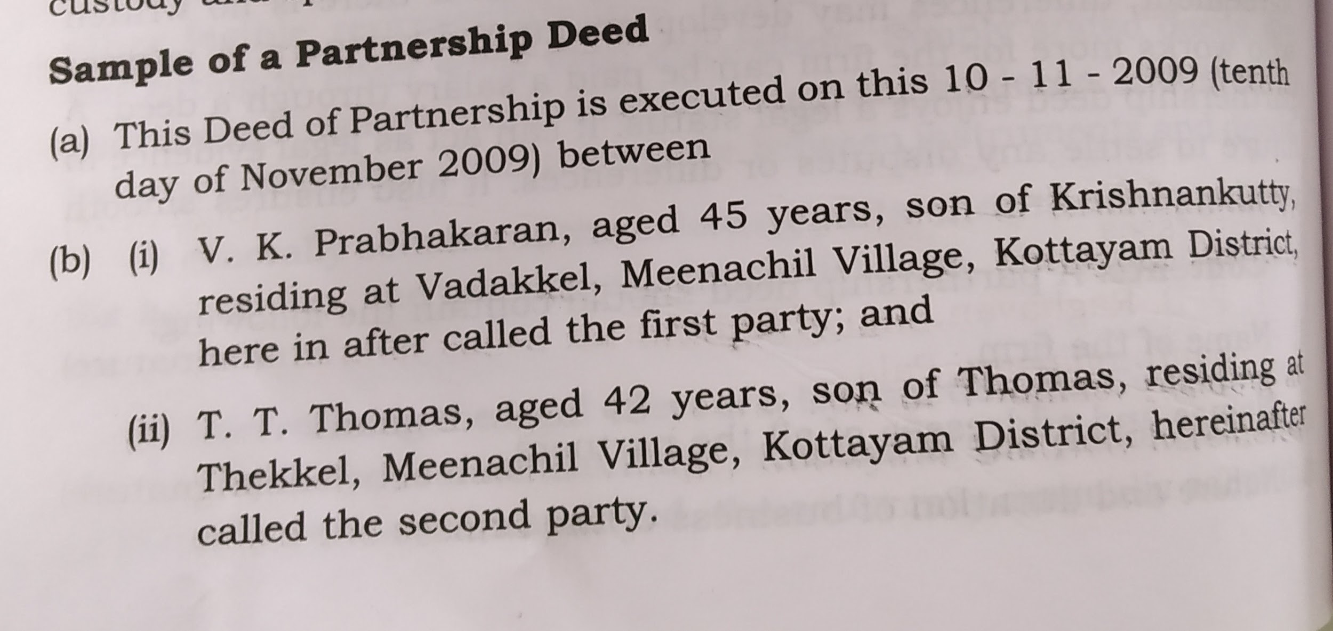
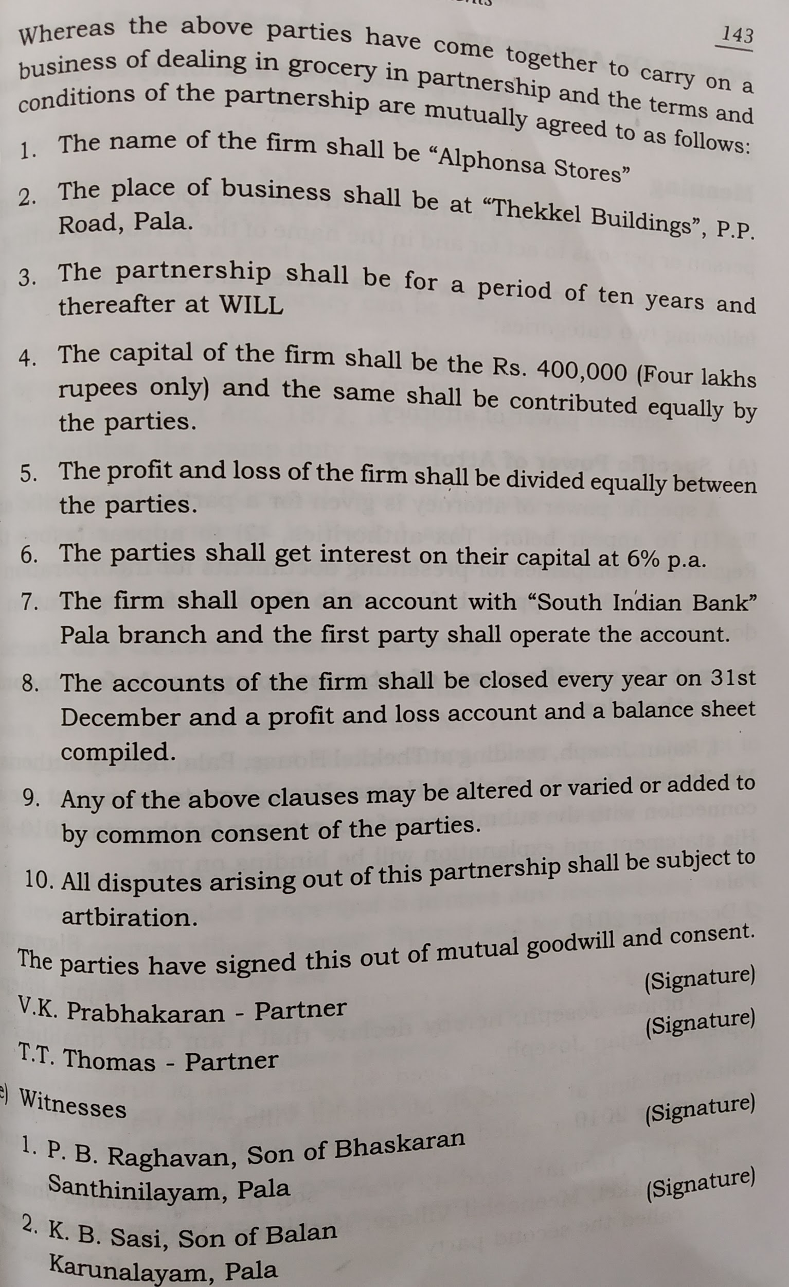

25. Explain structure of MIS?
- Operational elements :a. Physical components b. Processing Functions:
I. Hardware I Processing transactions
II Software II Maintaining master files
III database III Producing Reports
IV Procedures IV Processing Enquiries
V people- users and V Processing Interactive operating personnel support applications
C. Output to users:
I Transaction documents
II Reports
III Enquiry responses
IV Output of interactive support applications
- Operational function
- Levels of management activity- Strategic planning, Tactical planning and management control, operational planning and control
- Decision Support

