SAINTGITS COLLEGE OF APPLIED SCIENCES
Second Internal Assessment Examination, November 2018
B. Com First Semester (Computer Applications & Taxation)

BANKING AND INSURANCE

Total: 80 marks Name ……………
Time: 3 Hours Roll Number ……………
Section A
Answer any 10 questions. Each question carries 2 marks.

1. What is bank?
2. What is truncated cheque?
3. What is KYC?
4. What is double insurance?
5. What is meant by inchmaree clause in marine insurance
6. What is core banking?
7. What is General Lien?
8. What is a Garnishee order?
9. Explain Bancassurance.
10. What is Ru Pay Debit card?
11. What is foreclosure?
12. What is assignment of policy?
(10 X 2 = 20 marks)
Section B
Answer any 6 questions. Each question carries 5 marks.

13. What are the powers and duties of Banking Ombudsman?
14. Explain briefly the rights of a banker?
15. What are the advantages of RTGS?
16. What are the essentials of a valid cheque?
17. Explain Debtor- creditor relationship of banker and customer.
18. What are the different types of cheques.
19. Write a brief note on Group Insurance and its benefits?
20. What are the essentials of Fire Insurance?
21. Explain PMJDY.
(6 X 5 = 30 marks)
Section C
Answer any 2 questions. It carries 15 marks.

22. Explain Basel Norms.
23. What are the principles of insurance?
24. What is a cheque? What are the different types of cheque?
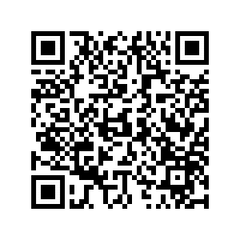
25. What is E-banking? Explain the advantages and limitation of E- Banking. (2 X 15 = 30 marks)

Scan QR code for the answer scheme

