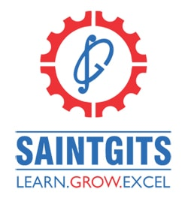
SAINTGITS COLLEGE OF APPLIED SCIENCES
PATHAMUTTOM, KOTTAYAM

FIRST INTERNAL EXAMINATION, FEBRUARY 2020
Department of V, Semester
DATA MINING
Total : 50 marks Time: 2 hours
Section A
Answer any 5 questions. Each question carries 2 marks.

1. What is a data warehouse?
2.What is a transactional database?
3. What is Prediction?
4. What is outlier?
5.What is classification?
6. What is a data cube?
Section B
Answer any 5 questions. Each question carries 5 marks.
7.What are the features of a data warehouse?
8. Explain data the architecture of a datamining system?
9.Explain different types of Normalization?
10.Explain world wide web mining?
11.Compare OLAP and OLTP?
12.Explain data cleaning?
Section C
Answer any 1 questions. It carries 15 marks.
13. Explain data Pre processing Methods?
14. Explain various data mining functionalities?

[Scan QR code for Answer Key]

