SAINTGITS COLLEGE OF APPLIED SCIENCES
PATHAMUTTOM, KOTTAYAM

FIRST INTERNAL EXAMINATION, FEBRUARY 2020
Department of Business Administration, Semester II

BUSINESS COMMUNICATION
Total : 50 marks Time: 2 hours
Section A
Answer any 5 questions. Each question carries 2 marks.

1. Define Communication.
2. What is meant by persuasion? Give an example of a situation.
3. What are the objectives of communication?
4. What are business letters?
5. State the purposes of a business letter.
6. What are adjustment letters?
Section B
Answer any 5 questions. Each question carries 5 marks.
7. Explain semantic barriers of communication.
8. Explain the different elements of communication
9. Discuss the importance of communication for business.
10. Explain the different formats of a business letter with illustrations.
11. Discuss the different parts of a business letter.
12. Write a circular stating opening of new branch with launching of new product.
Section C
Answer any 1 question. It carries 15 marks.
13. Discuss the 7C’s of communication.
14. What are employment letters? Draft specimens of employment letters

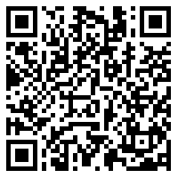
[Scan QR code for Answer Key]

