Scheme of Valuation/Answer Key-
(Scheme of evaluation (marks in brackets) and answers of problems/key)
APJ ABDUL KALAM TECHNOLOGICAL UNIVERSITY
SIXTH SEMESTER B.TECH DEGREE EXAMINATION, APRIL 2018
Course Code: CE366
Course Name: TRAFFIC ENGINEERING AND MANAGEMENT
Max. Marks: 100 |  |  |  | Duration: 3 Hours
PART A
 |  | Answer any two full questions, each carries 15 marks. |  |  | Marks
1 | a) | Car-pooling, peripheral parking schemes, chartered buses, staggering of office hours, internal shuttle service in CBD, parking restraint, road pricing, entry fee, priority for buses in traffic, restrictions on entry of trucks during day time…1mark per point |  |  | (10)
 | b) | Set of engineering measures to reduce speeds and volumes of motor vehicles in local areas to increase traffic safety.  Speed breakers or humps  Rumble strips  Crash barriers  Road narrowing or chicanes  Provision of separate cycle tracks …1mark per point |  |  | (5)
2 | a) | There is imbalance in directional distribution of traffic during peak hours. The morning peak results in heavy preponderance of flow towards the city centre and vice versa during evening peak. in either case the street space provided for opposing traffic is found to be in excess. This phenomenon is commonly termed as tidal flow. |  |  | (3)
 | b) | (i) to apportion greater number of lanes in multi-lane street to in-bound traffic during morning peak and to out-bound traffic during evening peak (ii) if there exists two parallel streets close to each other, wider of the two is set apart for heavier traffic during morning and evening peak |  |  | (2)
 | c) | Monitoring of traffic flow, provide information to drivers about road congestion, road closures, alternative routes, weather conditions and speeds to be observed. ATIS informs highway users about traffic jams, road closures, alternative routes and weather condition  Monitor incidents on road like vehicle breakdowns and collisions  Electronic collection of toll  Intelligent Vehicle-Highway System (IVHS)—vehicles are guided longitudinally and laterally by electronic devices.Advanced Vehicle Control System (AVCS) dispense the human control of vehicles and rely on computers  Traffic control on urban streets by using information on traffic flows and adjusting signal operations to reduce congestion and delay Asset Maintenance Management system covers the data on asset, the traffic using the asset, periodic condition survey data and use software packages to optimize maintenance interventions. Public Transport Management systems wherein fleet can be managed efficiently by analysing data on vehicle location, adherence to schedule and passenger loadings. Demand-Responsive Public Transport and Taxis can also be a part of the system.The use of GIS is extensively made.  Truck Transport Management Systems wherein the data on vehicle location, breakdown, accidents, detention etc. can be analysed and action initiated to improve operations. Electronic Road pricing to decongest city centres. |  |  | (10)
3 | a) | Regulations concerning the driver- Licensing of the driver, Requirements of physical fitness, Age of drivers, disqualification and endorsement of License, Offences and penalties-----2marks per point |  |  | (10)
 | b) | The courts have final say in matter of punishing the offenders. They interpret the law, assess the guilt and impose penalties. In India, the Motor Vehicles Act prescribes the penalties for different traffic offences (introduced in 1939 and revised in 1988. The Act is basically framed to codify the laws relating to motor vehicles. It does not cover the safety aspect of roads by highway authorities. It has various chapters for eg chapter IV deals with the registration of vehicles.Chapter V deals with the control of transport vehicles and so on. |  |  | (5)
PART B
Answer any two full questions, each carries 15 marks.
4 | a) | Basic Capacity: the maximum number of passenger cars that can pass a point on a lane or a roadway during one hour under the most nearly ideal roadway and traffic conditions, which can possibly be attained……2marks  Possible Capacity: the maximum number of vehicles that can pass a point on a lane or a roadway during one hour under prevailing roadway and traffic conditions…….1mark  Practical Capacity: the maximum number of vehicles that can pass a point on a lane or a roadway during one hour, without the traffic density being so great as to cause unreasonable delay,hazard or restriction to drivers freedom to manoeuvre under prevailing roadway and traffic conditions. This term is frequently referred to as design capacity. ……2marks |  |  | (5)
 | b) | 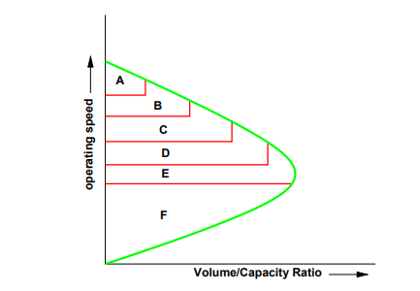  Figure…………marks Explanation….6marks  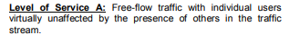  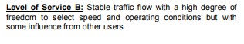  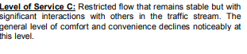  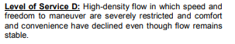  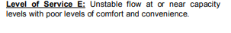  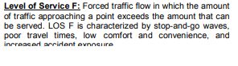 |  |  | (10)
5 | a) | Physical and operating conditions: width of approach, one-way or two-way operation, parking conditions  Environmental conditions: degree of utilization of an individual approach, variation of demand during the peak hour, population of the metropolitan area, location of interaction within the metropolitan area  Traffic Characteristics: turning movements, composition  Control Measures: traffic signals including cycle length,green time to cycle time ratio  Marking of approach lanes |  |  | (10)
 | b) | Based on number of experiments the maximum capacity of weaving sections of rotary has been computed. The practical capacity s taken as 80 percent of the maximum capacity and can be calculated from the following formula  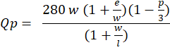  Where  Qp=practical capacity  w=width of weaving section in m  e= average entry width of rotary in m  l=length of weaving section between ends of channelizing island in m  p=proportion of weaving traffic |  |  | (5)
6 | a) | Calculation of pedestrian phase(green time and clearance interval)---2marks  Calculation of flow after giving correction to right turners and saturation flow(2888PCU/hr)---2marks  Calculation of lost time(31s) and optimum cycle time (140s)…..2marks  Calculation of green time for phases 49s N-S phase, 40s E-W phase)….2marks  Timing and phasing diagram…2marks |  |  | (10)
 | b) | Minimum vehicular volume, Interruption to continuous traffic, Minimum pedestrian volume, Accident Experience. |  |  | (5)
PART C
Answer any two full questions, each carries20 marks.
7 | a) | Vertical Alignment, Sight Distance, Super elevation, carriageway width, width and condition of shoulders, deficiency in road signs and road markings, junction design, pavement surface characteristics, median width, street lighting (min 6 points @2 marks per point) |  |  | (12)
 | b) | 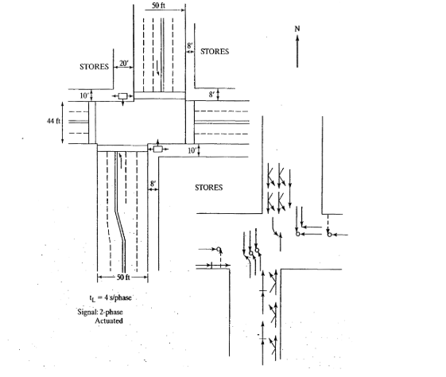  Figure:4marks Explanation: 4 marks |  |  | (8)
8 | a) | Traffic management measures like one-way streets , prohibited turns.  Legislative measures  Enforcement measures  Educational measures  Propaganda. (6 points 2marks per point) |  |  | (12)
 | b) | The system is in a steady state and has settled down. Its valid only when arrival and service patterns are sustained for indefinitely long periods of time and not for peaking situations or transient behaviour. It implies that traffic intensity 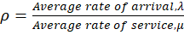 is less than 1  The number of customers is discrete  The population of potential customers is infinite  The arrivals are random in nature and poissonian distribution applies  There will be no simultaneous arrivals  There will be a single service channel. Separate modifications of the approach are available for multiple channels  The queue is single and is of infinite capacity  The order of service is first in first out  There is a single follow-on service discipline  The service times vary and follow an exponential distribution with mean rate |  |  | (8)
9 | a) | Computation of (1/40 veh/s), 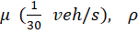(3/4)……..2 marks  Expected number of customers in the system =3……..1mark  Average length of the queue, which is the number of vehicles in the queue =2.25…….....1 marks  Average time spent by vehicle in the system =120s……..2marks  Average time spent by vehicle in the queue=90s……..2marks  Full credit maybe given to students who have attempted the same as the question is beyond the scope of the syllabus |  |  | (8)
 | b) | Figure…6marks Explanation……..6marks  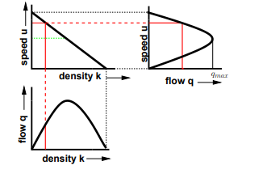 |  |  | (12)
****

