C |  |  |  |  |  |  |  |  | Total Pages: 3
Reg No.:_______________ |  |  |  |  |  |  | Name:__________________________
APJ ABDUL KALAM TECHNOLOGICAL UNIVERSITY
FOURTH SEMESTER B.TECH DEGREE EXAMINATION, JULY 2017
Course Code: CS204
Course Name: OPERATING SYSTEMS (CS)
Max. Marks: 100 |  |  |  |  |  |  |  | Duration: 3 Hours
 |  |  |  |  |  | Answer Key
PART A
Answer all questions. Each carries 3 marks.
1 |  |  | What are the advantages of peer-to-peer systems over client-server systems?  All nodes are peers and each may act as client/server .Services are provided by several nodes.  In client-server systems,server is a bottleneck.
2 |  |  | What are the advantages of loadable kernel modules?  The additional services are linked in via modules either at boot time or compile time. The kernel is provided with only the core components.
3 |  |  | Which are the different process states?  New,Ready,Running,Waiting and Terminated.
4 |  |  | What is the use of pipe system call?  Interprocess communication-Read and write on pipe.
PART B
Answer any two questions. Each carries 9 marks.
5 | a) |  | Differentiate between the operating System structures?  Simple,Layered,Microkernels, Modules,Hybrid systems. |  |  |  |  |  |  | (6)
 | b) |  | How does the use of bit-maps becomes space efficient?  Availability of a resource-indicated by 0 or 1.  Space complexity is less compared to hash function |  |  |  |  |  |  | (3)
6 | a) |  | Explain the process creation in Unix with the help of suitable example.  Creation  Fork()-create a new process  exec()-to execute the process. |  |  |  |  |  |  | (6)
 | b) |  | What is a PCB(Process Control Block)?  Each process is represented by a Process Control Block(PCB).  State,Program Counter,CPU Registers,Memory-Management Info etc. |  |  |  |  |  |  | (3)
7 | a) |  | Describe the differences among short-term, medium-term and long-term scheduling?  Long-term scheduler:selects process from job pool and loads into memory for execution.  Short term Scheduler:Selects one among those process and allocates CPU to one of them.  Medium Term Scheduler:deals with the concept of swapping |  |  |  |  |  |  | (6)
 | b) |  | With the help of a diagram ,describe the actions taken by the kernel to context switch between process?  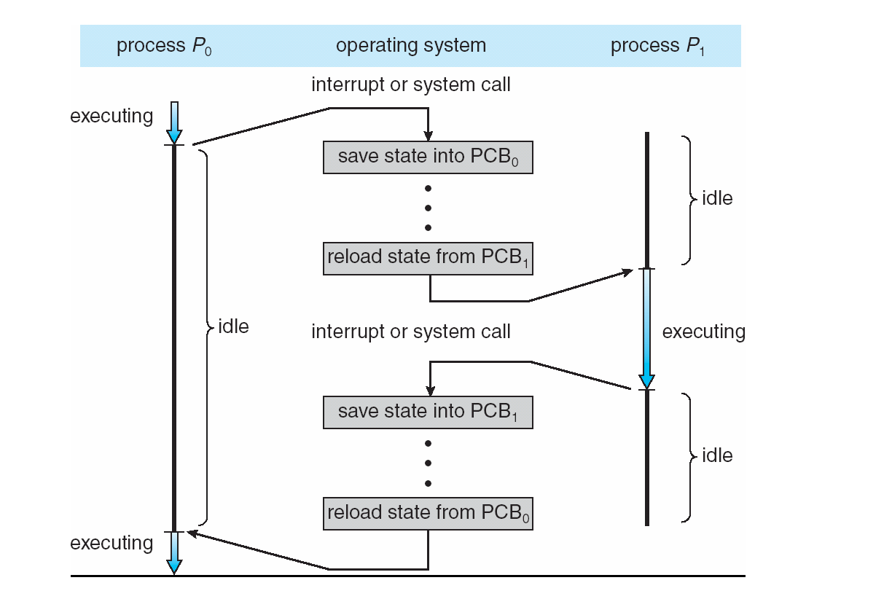 |  |  |  |  |  |  | (3)
PART C
Answer all questions. Each carries 3 marks.
8 |  |  | What are the three requirements to Critical Section Problem?  Mutual Exclusion,Progress,Bounded wait
9 |  |  | Describe how semaphores can be used as a synchronisation mechanism?  Use of signal and wait
10 |  |  | What is the main problem with Shortest Job First scheduling and what is its solution?  Starvation , To find length of next CPU burst - 2 marks  Solution-Exponential Averaging / Aging - 1 marks
11 |  |  | What are the conditions that lead to a deadlock?  Mutual Exclusion, Hold & Wait, Non-Pre-emption, Circular Wait
PART D
Answer any two questions. Each carries 9 marks.
12 |  |  | Enumerate the three classical problems of synchronisation?  Readers writers Problem,Producer-Consumer problem,Dining Philosophers problem |  |  |  |  |  |  | (9)
13 |  |  | Draw the Gantt Chart , find the average waiting time for the following algorithms  i)FCFS ii)Pre-emptive priority iii)Non-preemptive priority  Process Arrival Time(ms) Burst time(ms) Priority  P1 0 8 4  P2 2 6 1  P3 2 1 2  P4 1 9 2  P5 3 3 3  FCFS:P1,P4,P2,P3,P5  Average Waiting Time:12.8 ms  Pre-emptive:P1,P4,P2,P3,P4,P5,P1  Average W.T=9.2 ms  Non-preemptive:P1,P2,P3,P4,P5  Average W.T=10.6 ms |  |  |  |  |  |  | (9)
14 | a) |  | Discuss how Resource Allocation Graph can be used for deadlock avoidance?  Resource Allocation Graph-Diagram(3)  Existence of cycle:(2 marks) |  |  |  |  |  |  | (5)
 | b) |  | What are the measures to recover from a deadlock?  Process Termination,Resource pre-emption |  |  |  |  |  |  | (4)
PART E
Answer any four questions. Each carries 10 marks.
15 | a) |  | Given six memory partitions of 100KB,500 KB,200 KB,300 KB,600 KB (in order),how would the first-fit,best-fit and worst-fit algorithms place processes of size 212KB,417 KB,112 KB,426KB(in order). Rank the algorithms in terms of how efficiently they use memory.  Let the process be P1(212KB),P2(417 KB),P3(112KB),P4(426 KB).  First fit:P1-500KB,P3-200 KB,P2-600 KB,P4can't be allocated  Best Fit:P2-500 KB,P3-200 KB,P1-300 KB,P4-600KB  Worst Fit:P2-500KB,P3-300 KB,P1-600KB,P4 can't be allocated. |  |  |  |  |  |  | (5)
 | b) |  | Consider a logical address space of 64 pages of 1024 words each, mapped onto a physical memory of 64 frames.  a.How many bits are required in the logical address?  b.How many bits are required in the physical address?  a. 10 bits to address each of 1024 words(2^10)  Virtual Memory has 64 pages.(2^6).  Total bits required for logical address=(10+6)=16 2.5 marks  b. Physical Memory has 64 frames.(64=2^6)  Total bits required for physical address=(10+6)=16 bits 2.5 marks |  |  |  |  |  |  | (5)
16 | a) |  | Discuss the concept of Virtual File Systems  Diagram-2 marks  Explanation-2 marks |  |  |  |  |  |  | (4)
 | b) |  | Suppose that a disk drive has 200 cylinders numbered from 0 to 199.The disk is currently servicing at cylinder 100 and the previous request was at cylinder 120.The queue of pending requests in FIFO order is 23,89,132,42,187.  Starting from the current head position,what is the total distance(in cylinders) that the disk arm moves to satisfy all the pending requests for each of the scheduling algorithms?  i)FCFS ii)SSTF iii)SCAN  FCFS:100,23,89,132,42,187  Distance:421 cylinders.  SSTF:100,89,132,187,42,23  Distance:273 cylinders  SCAN:100,89,42,23,0,132,187  Distance:287 cylinders |  |  |  |  |  |  | (6)
17 | a) |  | Which are the different access methods of a file?  Sequential Access,Direct Access,Indexed Access. |  |  |  |  |  |  | (4)
 | b) |  | What are the different allocation methods of a file?  Contiguous, Indexed,Linked Allocation |  |  |  |  |  |  | (6)
18 | a) |  | Discuss the principles of protection?  Principle of least privilege |  |  |  |  |  |  | (3)
 | b) |  | How access matrix is used as a protection mechanism?  Matrix describing rights,copy rights,owner rights and modified matrix. |  |  |  |  |  |  | (7)
19 | a) |  | Consider the following segment table:  Segment Base Length  0 219 600  1 2300 14  2 90 100  3 1327 580  4 1952 96  What are the physical addresses for the following logical addresses?  - 0,430  - 1,10  - 2,500  - 3,400  - 4,112  a.(219+430)=649  b.(2300+10)=2310  c.IIIegal address as offset 500>100  d.(1327+400)=1727  e.IIIlegal address as offset 112>96. |  |  |  |  |  |  | (5)
 | b) |  | How is segmentation different from paging?  Paging is used to get a large linear address space without having to buy more physical memory. Segmentation allows programs and data to be broken up into logically independent address spaces and to aid sharing and protection.  Paging does not distinguish and protect procedures and data separately.  Segmentation distinguishes and separately protects procedures and data.  Unlike segmentation, Paging does not facilitate sharing of procedures.  Paging is transparent to programmers(system handles it automatically).  Segmentation requires programmer to be aware of memory limits as programmer  tries to allocate memory to functions and variables or tries to access read  only memory violation, which results in segmentation fault |  |  |  |  |  |  | (5)
20 | a) |  | Discuss the different aspects of contiguous memory allocation?  Memory protection,memory allocation and fragmentation. |  |  |  |  |  |  | (5)
 | b) |  | Discuss the steps in handling a page fault?  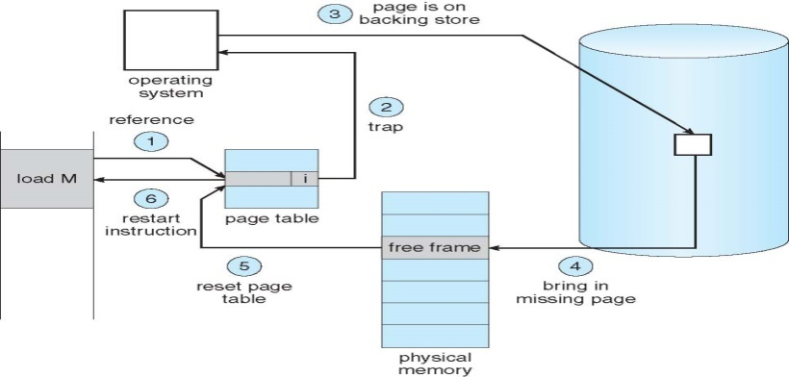 |  |  |  |  |  |  | (5)

